**PAC-MAN (Group 68)**

**Edward, Felix, Jason, Kelly, Lewis**

To make this project work, we will divide the work in a step-by-step basis instead of working in parallel (to avoid any git problems such as merging different versions of the game). One or Two people will be assigned each of the steps here.

1. **Creating the 2D Text-Based Map and Pac-Man**

This person is assigned with creating the 2D Map and Pac-Man. My idea is that the map should be created using the characters “|”, “_” and whitespace but if you find better alternatives then feel free to use those alternatives.

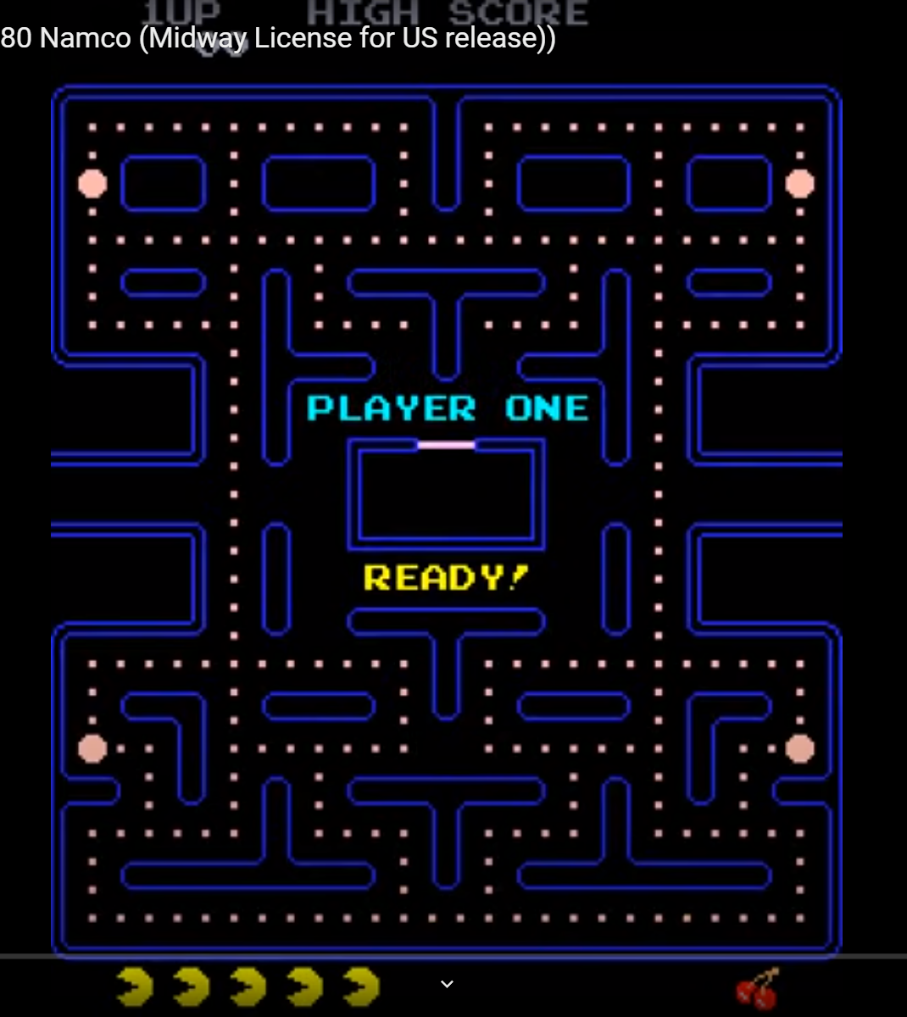

(Map of Pac-Man)

Pac-Man should be fully controllable with (WASD and arrow keys) and is able to move around the map, obeying the walls, so no going through the walls xD. You can use any character to represent Pac-Man, I leave this to you!

**Optional idea if you want to implement it:**

The map can be randomly generated or you can create several maps so that every time the player restarts after losing the game, they won’t be bored looking at the same map.

1. **Pac-Man’s food and the 4 ghosts + weak path-finding (2 People may work on this)**

These persons are in charge of creating the 4 ghosts, their path-finding and Pac-Man’s food (the tiny and big circles, up to you for the characters to represent them) that is scattered everywhere throughout the game as seen in the above map. If pac-man walks over the food, he automatically eats it and the food disappears.

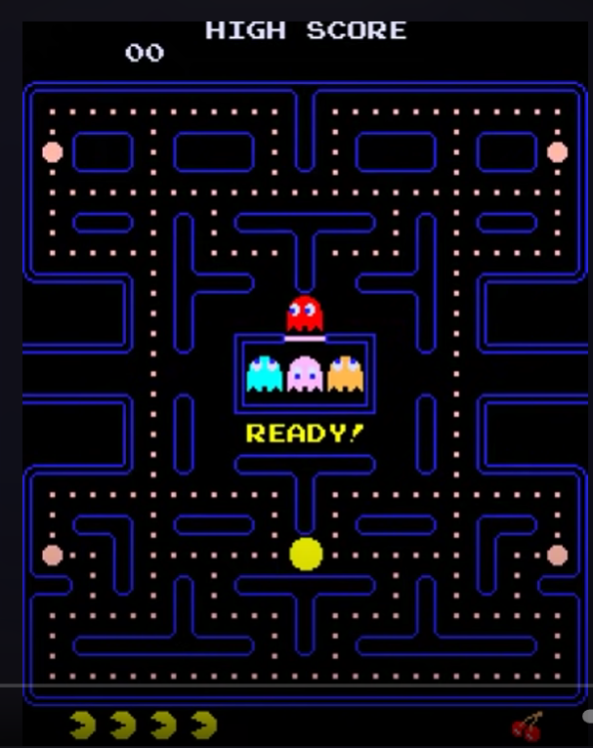

(Start of Pac-Man)

In the beginning of the game, only 1 ghost is active and running around in the map. The other 3 ghosts are trapped in the middle of the map.

When the game starts, 1 ghost immediately exits the center, thus 2 ghosts are now chasing Pac-Man.

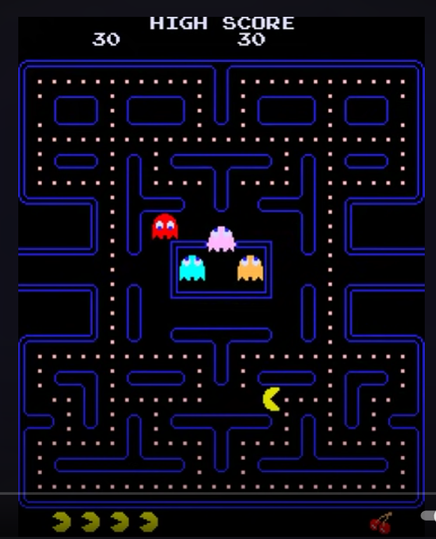

(1 Ghost exiting the map during the start of the game)

The blue ghost (left ghost that is stuck) will leave the center after 300 points (like in the original game) OR after 10 seconds (whichever you prefer). The orange ghost (right ghost) leaves the center after 900 points or 20 seconds (again, up to you).

The ghosts are expected to have a WEAK path-finding algorithm that leads to pac-man (the player). This algorithm should not be effective nor good at chasing Pac-Man, but good enough to cause difficulty for the player.

If the ghosts catch pac-man, pac-man dies and we restart the game. (You can create an animation for pac-man when he dies, like in the original game. Video of Pac-Man gameplay in the bottom of the google docs.)

IMPORTANT NOTE: You are not expected to create the power-up effect every time Pac-Man eats a big circle.

1. **Scoring System, Pac-Man’s Power-Up and Eating ghosts**

This person is assigned with making the scoring system, and handles pac-man’s ability after eating a big circle/ (power pellet).

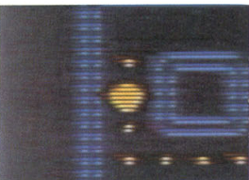

(Power Pellet)

You should create a scoring system, basically a display that shows the player’s current score and high score. Eating a small circle awards the player 10 points and eating a big circle (power pellet) awards the player 50 points. Make it so that if pacman manages to eat all the circles in the map, we restart the game, but:

1. Points are saved

2. The three ghosts stuck in the center are able to immediately exit the center and chase pac-man.

3. All circles are back

When pacman eats a big circle (power pellet), Pac-Man enters GOD MODE for 8 seconds (or whatever seems good). Basically, Pac-Man becomes invulnerable and is able to eat the ghosts. The ghosts should try to run away from Pac-Man. If eaten by Pac-Man, the ghosts will spawn back to the center of the map, but they can immediately exit the center and chase Pac-Man once again. If Pac-Man manages to eat a ghost, Pac-Man receives 400 points. If Pac-Man manages to eat a second ghost, Pac-Man receives (400 x 2) points and third ghost (400 x 3) points. So if Pac-Man manages to eat all 4 ghosts, Pac-Man receives (400 + 800 + 1200 + 1600) points or 4000 points in total.

**4. Polishing the game and making the main menu + assisting in cleaning code (Do this from the start of the project to submission)**

This person is in charge with smoothing and cleaning the code + polishing the game. Polishing here does not only mean fixing the bugs in the game, but also making the game look nicer and overall the interface should be better. This person is also in charge of making the main menu + options + the statistic system.

**OTHER NOTES:**

In the original game there are fruits and also pac-man has 5 lives. We can maybe implement this but this is totally optional.

Feel free to give suggestions or even critiques with this system in the WA Group.

References to understand the game:

**Original Pac-Man Manual** (<https://www.nintendo.co.jp/clv/manuals/en/pdf/CLV-P-NABME.pdf>)

**Video**

(<https://www.youtube.com/watch?v=dScq4P5gn4A>)

<Document created by Edward>